Task-1c
View memory layout of 1d and 2d array and strings.
#include<stdio.h>
#include<stdlib.h>

int main()
{
int arr[10]={1,2,3,4}; //1d array
int arr1[3][3]={1,2,3,4,5,6,7,8,9}; //2d array
char str[20]="hello world"; //1d array
char str1[4][20]={"gfg","accompany","udemy","coursera"}; //2d array
return 0;
}

Memory layout 1d array and printing it in gdb.
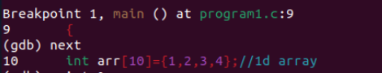
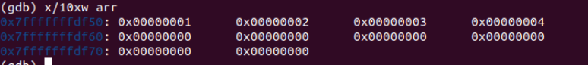

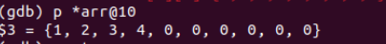

Memory layout 2d array and printing it in gdb.

Memory layout of 1d string and printing it in gdb.
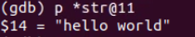

Memory layout of 2d string and printing it in gdb.
